3.1.

|  |  |  |  |
| --- | --- | --- | --- |
| X1 | X2 | X3 | Y5 |
| 0 | 0 | 0 | 1 |
| 0 | 0 | 1 | 0 |
| 0 | 1 | 0 | 1 |
| 0 | 1 | 1 | 0 |
| 1 | 0 | 0 | 0 |
| 1 | 0 | 1 | 1 |
| 1 | 1 | 0 | 0 |
| 1 | 1 | 1 | 1 |

3.2.

1. Смотрим на строки, где Y = 1:

* Строка 1: X1 = 0, X2 = 0, X3 = 0
* Строка 3: X1 = 0, X2 = 1, X3 = 0
* Строка 6: X1 = 1, X2 = 0, X3 = 1
* Строка 8: X1 = 1, X2 = 1, X3 = 1

1. Теперь составим конъюнкцию для каждой строки:

* Строка 1: ¬X1 ∧ ¬X2 ∧ ¬X3
* Строка 3: ¬X1 ∧ X2 ∧ ¬X3
* Строка 6: X1 ∧ ¬X2 ∧ X3
* Строка 8: X1 ∧ X2 ∧ X3

1. Теперь объединим эти конъюнкции вместе:

Yсднф = (¬X1 ∧ ¬X2 ∧ ¬X3) ∨ (¬X1 ∧ X2 ∧ ¬X3) ∨ (X1 ∧ ¬X2 ∧ X3) ∨ (X1 ∧ X2 ∧ X3)

3.3.

1. Смотрим на строки, где Y = 0:

* Строка 2: X1 = 0, X2 = 0, X3 = 1
* Строка 4: X1 = 0, X2 = 1, X3 = 1
* Строка 5: X1 = 1, X2 = 0, X3 = 0
* Строка 7: X1 = 1, X2 = 1, X3 = 0

1. Теперь составим дизъюнкцию для каждой строки:

* Строка 2: (X1 ∨ X2 ∨ ¬X3)
* Строка 4: (X1 ∨ ¬X2 ∨ ¬X3)
* Строка 5: (¬X1 ∨ X2 ∨ X3)
* Строка 7: (¬X1 ∨ ¬X2 ∨ X3)

1. Теперь объединим эти дизъюнкции вместе:

Yскнф = (X1 ∨ X2 ∨ ¬X3) ∧ (X1 ∨ ¬X2 ∨ ¬X3) ∧ (¬X1 ∨ X2 ∨ X3) ∧ (¬X1 ∨ ¬X2 ∨ X3)

3.4.

Карта Карно

|  |  |  |  |  |
| --- | --- | --- | --- | --- |
| X1 \ X2X3 | 00 | 01 | 11 | 10 |
| 0 | 1 | 0 | 0 | 1 |
| 1 | 0 | 1 | 1 | 0 |

Минимизированная ДНФ:

(X1∧X3) ∨ (¬x1∧¬x3)

3.5.

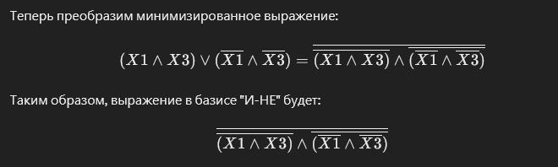

3.6.

|  |  |  |  |  |
| --- | --- | --- | --- | --- |
| X1 \ X2X3 | 00 | 01 | 11 | 10 |
| 0 | 1 | 0 | 0 | 1 |
| 1 | 0 | 1 | 1 | 0 |

Минимизированная КНФ:

(¬X1∨X3) ∧(X1∨¬X3)

3.7

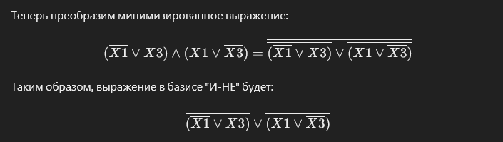

3.8. (05)

|  |  |  |  |  |
| --- | --- | --- | --- | --- |
| X1 | X2 | X3 | X4 | Y5 |
| 0 | 0 | 0 | 0 | 0 |
| 0 | 0 | 0 | 1 | 1 |
| 0 | 0 | 1 | 0 | 0 |
| 0 | 0 | 1 | 1 | 1 |
| 0 | 1 | 0 | 0 | 1 |
| 0 | 1 | 0 | 1 | 1 |
| 0 | 1 | 1 | 0 | 1 |
| 0 | 1 | 1 | 1 | 0 |
| 1 | 0 | 0 | 0 | 0 |
| 1 | 0 | 0 | 1 | 1 |
| 1 | 0 | 1 | 0 | 0 |
| 1 | 0 | 1 | 1 | 1 |
| 1 | 1 | 0 | 0 | 1 |
| 1 | 1 | 0 | 1 | 1 |
| 1 | 1 | 1 | 0 | 1 |
| 1 | 1 | 1 | 1 | 0 |

3.9

∨ ¬X3

Yскнф = (X1 ∨ X2 ∨ X3 ∨ X4) ∧ (X1 ∨ X2 ∨ ¬X3 ∨ X4) ∧ (X1 ∨ ¬X2 ∨ ¬X3 ∨ ¬X4) ∧ (¬X1 ∨ X2 ∨ X3 ∨ X4) ∧ (¬X1 ∨ X2 ∨ ¬X3 ∨ X4) ∧ (¬X1 ∨ ¬X2 ∨ ¬X3 ∨ ¬X4)

|  |  |  |  |  |
| --- | --- | --- | --- | --- |
| X1X2 \ X3X4 | 00 | 01 | 11 | 10 |
| 00 | 0 | 1 | 1 | 0 |
| 01 | 1 | 1 | 0 | 1 |
| 11 | 1 | 1 | 0 | 1 |
| 10 | 0 | 1 | 1 | 0 |

**Минимизированная КНФ:**

(X2∨X4)∧(¬X2∨¬X3∨¬X4)

